(Approx. 1201 words)

Another Unusual Problem – Why can’t I get to OneDrive.com?
By Phil Sorrentino, Contributing Writer, The Computer Club, Florida
The Journal of The Computer Club, Inc.
http://scccomputerclub.org / Philsorr.wordpress.com
philsorr (at) yahoo.com

The last time I wrote about an unusual problem was September 2013. That turned out to be a kinked USB cable between the computer and a printer. Since then I’ve seen many problems, but most have been of the garden variety - like malware infections, out-of-date printer drivers, wrong file associations, misplaced files, lost passwords, CPU and hard disk failures, etc., but this latest problem is very different. The problem manifested itself one day a few months ago, but I thought it was just a temporary situation, so I didn’t pay much attention to it. Then, after a good period of time, it dawned on me that the problem had been going on for at least five or six weeks. The problem was that I could not get to the OneDrive website to get the files I had put there. I had no trouble getting to all of the other websites that I typically use, like yahoo.com, google.com, cnn.com, and scccomputerclub.org. I have five computers at home; three are connected by Ethernet cable to the router (one is windows 7 and the other two are windows 10) and the other two use wi-fi (both of which are windows 10), but it didn’t matter, none would connect to OneDrive. Onedrive.live.com would appear and stay in the browser address bar, but nothing else would happen. I could get to OneDrive from other locations, like the computer lab, using my laptop or the computer lab computers. I could get to OneDrive from a friend’s home. I could even get to OneDrive using my Android tablet at my home. But I couldn’t get to OneDrive with any of my windows 10 or windows 7 computers. It was very perplexing.

Over the past year or so I have been using OneDrive as a vehicle to distribute information to other people. I have sent a large number of pictures to family members using OneDrive. I have distributed class notes to students using OneDrive. And I have used OneDrive to show videos to people I have been visiting. OneDrive, or any of these Cloud Storage services, is really a great place to keep files that you want to have accessible from anywhere (except from my house). Fortunately, I have a cloud account with Dropbox, Google Drive, and Box, all of which can be used for the same purposes, so I was able to continue distributing and accessing files, only from a different cloud source. But, what was going on with OneDrive?

It seemed like my computers didn’t know where OneDrive was. The first thing I thought of was that I had gotten on some black list and I was being kept out of OneDrive for some unknown reason, but there was no real substance behind that thought. Next, I thought maybe my router needed a software update. I checked with my router’s manufacturer and sure enough there were two updates that I didn’t have. I updated the router software, but unfortunately no luck, the problem was still there, I still couldn’t get to OneDrive. It still looked like my computers did not know where OneDrive was.

When I mentioned this problem to my son, he suggested it might be the DNS server. This thought eventually led to a solution (again, that college education paid off). So, what tells the computer, really the browser, where to go on the internet? Well, you would think that we do, by the name we put in the address bar of the browser, like www.yahoo.com. But, the address on the internet actually takes the form of an IP address, which is a collection of 4 decimal digits separated by periods. For example, when I researched the address for yahoo.com, I found 98.138.253.109, (actually yahoo.com probably has many IP addresses.), and the IP address for scccomputerclub.com was reported as 192.185.77.210. So that we mortals do not have to memorize the numerical IP address, there are computers out there on the internet whose sole job is to make the address conversions from names to numbers. These computers are called Domain Name System servers (or DNS servers), and a DNS server is typically assigned to you by your Internet Service Provider (ISP), Brighthouse or Frontier for most of us. A DNS server is a server computer that contains a database of public IP addresses and their associated host names, and typically serves to resolve the former to the latter, as requested. (Think of it as a device that translates the word address that you type, to a numerical address that is then used by the computer.) So, in summary, when you attempt to go to an address on the internet using your browser (Edge, Chrome, Internet Explorer, etc.), the address you put into the browser’s address bar is sent to a DNS computer where it is converted to a numerical IP address to which your browser is then connected.
There are many DNS servers on the internet, so which one do I use? Maybe the one I am using is giving me the problem, I thought. The DNS server that a computer uses is defaulted to be one that your ISP provides to you, and is a technical detail that is buried way down in the networking software. One way to get there is to go to the Control Panel and select “Network and Sharing Center” (view by large icons). Next, click “change adapter settings”, then right-click on your connection and click Properties. Next in the “This connection uses the following:” select “Internet Protocol Version 4 (TCP/IPv4)”, and then click Properties.
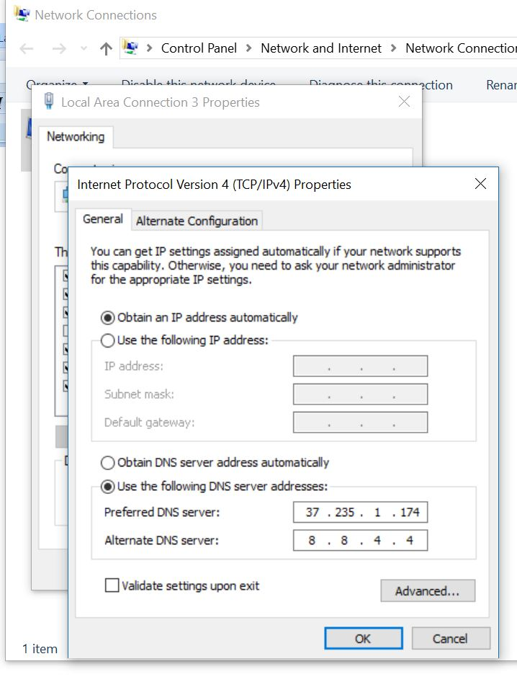
The final window looks like this except that the “obtain DNS server automatically” button will be selected (by default). In order to use a specific DNS server, select “Use the following DNS server addresses:” and then insert the IP addresses of a primary and a secondary DNS server.

But what DNS server should I use? Well, you should probably use the DNS server that is provided by your ISP, unless you are having a problem similar to the one that is being explored here. If you want to use a different DNS server there are some that are available to the public for free. Google provides 8.8.8.8 as a primary server and 8.8.4.4 as a secondary server. And FreeDNS provides 37.235.1.174 as a primary server and 37.235.1.177 as a secondary server. Try one of these if you are having difficulty reaching a known website. As you have probably guessed, I tried the FreeDNS servers and now I can reach OneDrive, and life is back to normal. I have concluded that the DNS server that I was using, for some reason, was not translating the words to numbers correctly. And yes, I did have to do this on each of the computers I wanted to use, at home, with OneDrive. (Though there is a change that you can make in the router that would affect all the devices that used that router, but that might be the subject of a future article.)

